# **Cr Adrian McRae - The Great Debate - Business and Community 27 Nov 2024.mp3**

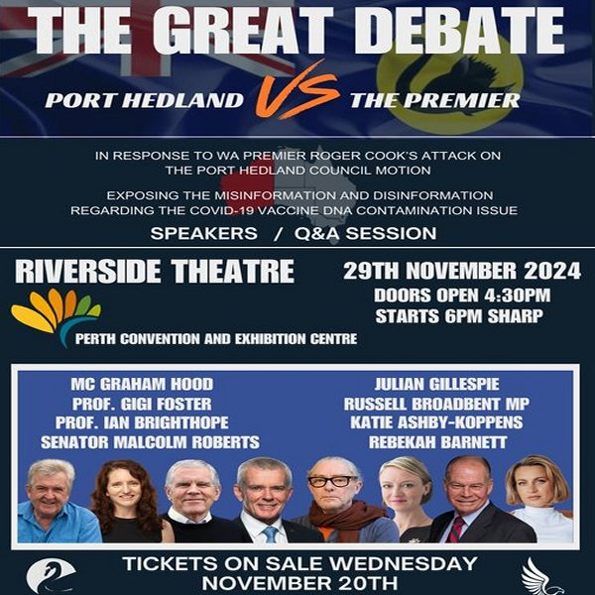

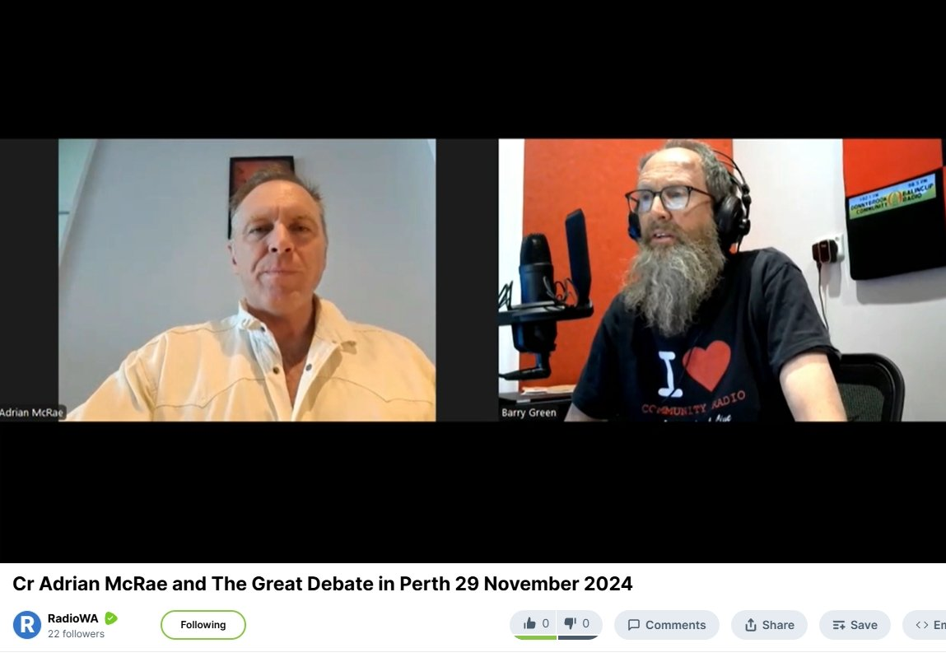

Port Hedland Motion : <https://porthedlandmotion.info>

Book The Great Debate 29 November 2024 : <https://premier.ticketek.com.au/shows/show.aspx?sh=PORTHEDL24>

Video interview : <https://rumble.com/v5tk96b-cr-adrian-mcrae-and-the-great-debate-in-perth-29-november-2024.html>

Audio interview : <https://soundcloud.com/dbcommunityradio/cr-adrian-mcrae-the-great>

**Barry Green:** Lady Gaga on Paparazzi on Donnybrook- Balingup Community Radio. Business and community roundup sponsored by the Donnybrook- Balingup Chamber of Commerce. My guest this morning is Adrian McRae. Councillor McRae from Port Hedland. G'day, Adrian.

**Adrian McRae:** Good morning Barry. How are you, mate?

**Barry Green:** I'm well. Thanks. So your actions at the Port Hedland Council are reverberating around the world, bringing to the attention of the authorities that some stray DNA that's been found in the Covid injections. What's happening? What's happening there for our listeners?

**Adrian McRae:** Look, um, last year, actually, it's taken more than a year to get to where we are. It's probably taken, you know, probably taken five years. But, look, last year, uh, a bunch of vials were, um, shipped to a number of scientists in, in Canada and North America and Europe. Um, just for interest's sake. They wanted to see, you know, just to see, of course, there's so much conspiracy and conjecture around what's in these things. People talking about all these different nanobots and graphene oxide and all these things. So, so are a bunch of bunch of activists and legal minds around, around the world, actually Australia included, um, got their hands on a number of vials. They, they shipped them to Canada and North America and some, some went to Europe. And what they sent it to some very preeminent scientists who, uh, who kind of went to test these things and didn't really test them with any preconceived notion. They were kind of half expecting to be able to debunk and, and, uh, you know, basically point out that these things, you know, they didn't have any issues with them. And, and what was actually first, um, first discovered by Kevin McKernan. Uh, he's a he's a very, um, eminent geneticist in the US. He was actually head of the Human Genome Project at MIT. You know, the probably the one of the biggest collaborations of, um, people in the biomedicine, medical, medical field in the last probably 50 years. They came together and they unraveled the human genome over a period of 12 years, one of the biggest assemblies of the greatest scientists in the world.

**Adrian McRae:** And Kevin was the director on that. And he found he found this unbelievable levels of DNA contamination in the mRNA, particularly the Pfizer and the Moderna. And he was a little bit unsure of, you know, how do how do you release such information like that? Um, a few other scientists got their hands on vials, and it ended up being, uh, Doctor David Spieker in Canada, uh, molecular biologist, um, a molecular virologist, um, in, in Canada. And, um, he, he discovered and reiterated what, uh, reiterated what, uh, Kevin McKernan had found. And he also found a bunch of other things, but he, um, he was the first one that put his hand up to say that this is, uh, this is a major problem. And he he kind of blew the whistle. And he obviously became quite famous around that. And hats off to David for having the bravery to do that because, you know, obviously in making announcements like this can have very negative effects on the university or the institutions that they work for. They can be sued. They can. They have their personal credibility dragged over the coals. They get smeared from one side of the world to the other, because Big Pharma does have some serious, you know, media power, particularly in North America. Um, and so moved forward, uh, pretty much 12 months, you know, this this message was getting out and, and David was speaking in many places around the world.

**Adrian McRae:** And of course, uh, um, Russell broadband member of Parliament for representative for Monash in Canberra. Um, got his hands on this information and he, he wanted it reiterated by, uh, you know, a number of other scientists. So he, he checked he checked that the information was valid with a number of scientists. And he wrote a letter back in, back in September to the prime Minister saying, Prime Minister, we've been given this new information on these, uh, these mRNA shots, particularly the Pfizer and the Moderna. We need to stop this until until we can prove that these things aren't contaminated like these eminent scientists around the world are saying they are. Of course, there was no response from the Prime Minister. So, um, Russell Russell had the, uh, you know, he had the, uh, the brains. He sent another letter, and now he had 52 of the eminent scientists, legal minds, academics and activists around the world signed on to his letter, uh, his second letter, which basically also consisted of the science, um, from Doctor David speaker. It also had a scientific summary from scientists all over the world that put their technical science into layman's terms to explain the ramifications of what this DNA contamination could mean for any of those people that have taken the jab, and also those still, still yet to take it or are still lining up to to get another booster.

**Adrian McRae:** And so, um, of course, this fell on deaf ears in Canberra, and, uh, the Prime minister never responded to, uh, Russell Broadbent. And so, as fate should have it, I happen to be good friends, personal good friends with both Russell Broadbent and also with David Speaker. In Canada, I became good friends with David in the Geneva World Health Organization. World Health Organization rallies in Geneva back in May and June earlier this year. And so, um, being being a freshly elected councillor, I, uh, I floated the idea with, um, a few, a few other councils in headland because we have a nurse on council up there who's seeing some crazy, uh, you know, she's just she's dealing with new cancers and really aggressive, crazy cancers every day of the week. Um, and also other councils that, that have, you know, that are just seeing and hearing this stuff that have, you know, actually been personally affected by the jab as well. And so, um, we called a special council meeting and I thought we might be able to give, uh, give um, Russell Broadbent some support in Canberra to maybe Port Hedland might make a bit of noise because if Port Hedland was able to vote a motion like this forward, obviously Port Hedland being the, uh, shall we say, you know, the engine room of Australia as the Prime Minister's all like to call it. Um, if Port Hedland made a noise about this.

**Adrian McRae:** It would get some, it would get some attention. So we called a special meeting of council. Three of us signed a document to call a special meeting of council. And we were fortunate to to get the vote over with an absolute majority, five votes to two, to basically support um, Russell Broadbent and his actions in, um, in Canberra with the Prime Minister. Now, I was extremely fortunate that, um, you know, for the last few months I've had, uh, um, my good friend Julian Gillespie, who's been sort of such a, such an instrumental, um, piece of the puzzle in all of these legal actions, the big legal actions happening in, uh, around, around Australia. He happened to be staying with me, and I had his, you know, his amazing mind and, um, and knowledge. And so he he helped us put the motions together and wrote some beautiful motions. And so Port Hedland passed with absolute majority to to share this information with every councillor, every mayor, every, every, every city, every council in the country. We sent letters to the Prime Minister demanding a demanding a suspension of these vaccines until they can prove their safety. We wrote to the Commonwealth Secretary for health, we wrote to the Federal Minister for Health and Aged care. We wrote to the Premier of WA. We wrote to the the Minister of Health in WA, and we also sent our letters to every health care practitioner in our town. Um, basically letting them know that this of this new information, which clearly wasn't being disseminated.

**Adrian McRae:** Um, from, you know, from within, you know, government authorities. Now, of course, our motion, uh, our motion, once we got it passed, um, gained some serious traction around the world somewhere. Look, I don't I'm only, uh, I lost count. I was trying to. I was using analytics, trying to work out how many times we'd been shared and viewed around the world. But, uh, you know, a few weeks ago, it was well over 60 million. We're probably in the vicinity of 80 to 90 million views around the world on our motion. This created a lot of energy. A lot of, um, people around the world started asking questions. There was a lot of, um, obviously media started talking about this and, um, it drove the TGA to to make a statement. And the TGA, of course, came forward and said, uh, look, David Speaker is a conspiracy theorist. All this, this notion of, uh, got it. We've got it covered. We've already checked this. We've we've checked it. It's safe and, you know, safe and effective, all the usual catchlines and, uh, and it's misinformation, it's conspiracy, and it's, uh, and it's, you know, it's it's been, you know, they're basically saying they've debunked it. Now, what the TGA didn't tell the people of Australia is, one, they didn't bring any science forward to show that they've been able to disprove this because they don't have the science, period.

**Adrian McRae:** That's just, you know, anyone that's following what's going on here knows they don't have the science. And two, just as fate would have it, I happen to have at our council meeting a freedom of information request number 5286. I've got it here beside me because it's, uh, you know, I'm sort of using this and talking, Talking to this, to so many different counselors and people around around the country and the Freedom of Information request. This was sent by Rebecca Barnett earlier this year asking the TGA, can you please tell us what techniques you are using, what science you are using to to to make these public statements in the Senate estimates hearings, when Rennick and Antic and and Babbitt and Malcolm Roberts and all these all these wonderful senators are asking the TGA, tell the truth, tell us, tell us, you know, and of course, these are this is you just shut up. You don't know what you're talking about. We've already done the science. And they're saying that the science is not validated. Their science is better than the top scientists in the world, in the US and Canada and and and in Europe, even, even, you know, even Didier Raoult, the number one biochemist in the world, the number one ranked biochemist in the world, they have rankings like tennis players. And he is the number one biochemist in the world, has come out last week and confirmed the DNA contamination, which is frightening. Or this you know, when when you've got the number one, um, you know proving proving the, you know, the worst possible case.

**Adrian McRae:** You know, it's what we hoped wouldn't happen. But now Didier Raoult has come out and going. Yeah, this is exactly as, as, you know, as these people are saying, okay, TGA response. This TGA response is from the TGA says that they are using the qPCR to measure the DNA contamination. Now, funnily enough, the TGA didn't expect us to have done our research. And again, because of the amazing research of Julian Gillespie and Katie Ashby and Rebecca Barnett, we have the Moderna patent. The Moderna patent, which Moderna since 2018, holds the world patent for removing DNA fragments from mRNA drugs, mRNA injections. And in Moderna's own patent, they state clearly that you cannot use the qPCR technique to quantify or measure DNA contamination, quite simply because it doesn't work, it does not give you even a fraction of the DNA contamination. This is the science. This is the science that the Moderna even says in their own patent is the science that you cannot use to quantify DNA contamination. And now the TGA is flat out lying. They are just they are just gaslighting Australians, gaslighting senators. And now they're in a situation where we've caught them out lying and they refuse to do the science, which proves it's safe and effective. This test can be done for as little as $10 and they won't do it. Yep.

**Barry Green:** Okay, so there's apparently appalling quality control. So not everybody has had necessarily the bad batches. But you've got an event on this Friday at uh, at the convention center. Tell our listeners about that because it's a great lineup of speakers. And the more people we can get there, the better.

**Adrian McRae:** Um, yeah. Look, thank you for bringing that up. We, um, I went overseas with, uh, John Shipton, Julian Assange's father. Uh, soon after the when we went over to the BRICs conference, we wanted to be there while history was being made in the Global South with regard to this new political and economic paradigms that are being put forward by China and Russia. And of course, I've come from a town that relies very much on China in Port Hedland. And it's interesting for me to understand where where the world politics is going. What's the future of my town if if China is going to start doing their trade in different currencies, different denominations? So for me, it was really interesting to to be in Russia while the while the BRICs event was happening. Now, of course, the Premier attacked me quite ferociously while I was overseas. He demanded my resignation. He demanded if I he said if I wasn't, if I don't resign, you know, the town of Port Hedland will be able to find a way to have me removed and very aggressively attacking me. And the point he was attacking me for was because the town of Port Hedland, he's blaming, he's lying, laying the blame on me because the town as a town voted in absolute majority to support a motion that I put forward to ask the question of him, remember, he was the health minister when all this nonsense was rolled out on us and these jabs were rolled out on us.

**Adrian McRae:** And he's now he's now in a very awkward position because obviously coming into an election, he needs to be getting the support and the trust of the people. When you know what I've, what what what we've what we've uncovered in Port Hedland is showing clearly that, uh, you know, the stuff that he is saying, he's obviously repeating. I don't think he even understands himself. He's just repeating the lies of the Australian government, who's repeating the lies of the TGA and the TGA, funded 96 by industry, is repeating the lies of industry, of Big Pharma. And so after I got back from Russia two weeks ago, two weeks ago, um, you know, just just gone two weeks now, um, I put it by a few of my great friends here, and, and I was still getting slandered all across the media. Six PR came after me consistently while I was away. They promised a right of reply. Of course, they refused to let me on air. And uh. And so I decided, um, well, what a great opportunity. While there's energy in the air we've had, like I said, somewhere around 80 million views on the on the Port Hedland motion. Let's bring the top the top academics, scientists, uh, investigative journalists. Let's bring them here and explain the situation so people of Australia can make up their own mind as to who's telling the truth. Is it is it is it the town of Port Hedland and Adrian McRae, or is it the premier and and and the Australian government, the TGA? So I decided to bring all the great minds that are that have been fighting this for a number of years to Perth.

**Adrian McRae:** And so we're putting on an event called the Great Debate. Port Hedland versus the premier on Friday night in the convention centre. It's only $29 a ticket. It's probably the most important event anyone will ever go to. It's going to teach, you know, for those people that have, um, you know, unfortunately, you know, been mandated or coerced into taking this, this injection, they may not have wanted it or if they have taken it and they've seen members of their community with adverse health effects, I strongly, strongly encourage you to come to this event. Um, I'll give tickets away for free to anyone who can't afford can't afford the entry fee. It's so important. This event is too important. Um, Nationally, politically and from a health perspective of all Australians and not just all Australians, as people all over the world took this stuff. And so I'm bringing the information to to the people of Perth and, and hoping that, you know, we I expect we've got some big channels that are going to be broadcasting this event live. We expect more than 100,000 people to be watching live. And it'll it'll hopefully start to change, start to bring this whole contamination issue, which is so frightening and so important into the conversation across Australia and across the world.

**Adrian McRae:** And we've already started that with the Port Hedland motion. I think this event will be the will be the game changer that, um, gets, because already other councils around the country are following in our footsteps. We've had Ceduna in South Australia follow us. We've had West Tamar in Tasmania. There are many big city councils along the eastern seaboard that are going to bring this up. I can't name those councils until the motions have been tabled at council level because I'd be giving giving the, you know, what's happening away prior to it being public. And so, um, yeah, the event on the event on Friday is basically an educational, uh, educational, um, a real life documentary of how we got to where we are, how this contamination issue came to be discovered, and, and why it's so dangerous, and what people can do about, uh, you know, if they've been injected, what they can do to get this, um, you know, get this stuff as best they can out of their bodies because this is really frightening. What, uh, what the ramifications are if this DNA contamination is real. And so far, it looks everyday scientists are stepping up all around the world going, okay, so the the contamination issue is real, and it's, um, you know, it's really frightening where this is going to be heading. Yeah.

**Barry Green:** If, uh, to fix a problem, you've got to address the cause. You've got to acknowledge you have a problem. So this is what's happening so people can book online. Can people buy tickets at the door?

**Adrian McRae:** People can buy tickets at the door. They're not accepting. Uh, unfortunately, it's a ticket tech policy. They don't accept cash, but you can buy tickets at the door with credit card or whatever. Um, tickets are available online on the ticket website. Um, it's in it's in the Riverside Theatre. So Perth's biggest theatre. Um, it's, uh, it's, you know, obviously we've got, um, you know, a lot of interest, a lot of people. It's only it's only been on sale. Hasn't even been on sale for a week yet. So, um, it's, uh, you know, a lot of people have. We've already sold close to just over 600 tickets. We expect another, um, 5 or 600 to sell before, um, before the weekend. So it will be a big show and certainly, um, it'll be one of the most important shows anyone can go to.

**Barry Green:** Well, thanks so much, Adrian. Thanks for your leadership. And we'll post this online later today and include a link to <https://premier.ticketek.com.au/shows/show.aspx?sh=PORTHEDL24> , site in the associated text. Thanks so much.

**Adrian McRae:** Awesome, awesome Barry look forward to meeting you there, mate.

**Barry Green:** Absolutely. I've been talking to Adrian McRae, the organiser of the Great Debate to be held in Perth on Friday, and you can get your tickets online now. We'll go to some music. This is Neil Diamond and America.